
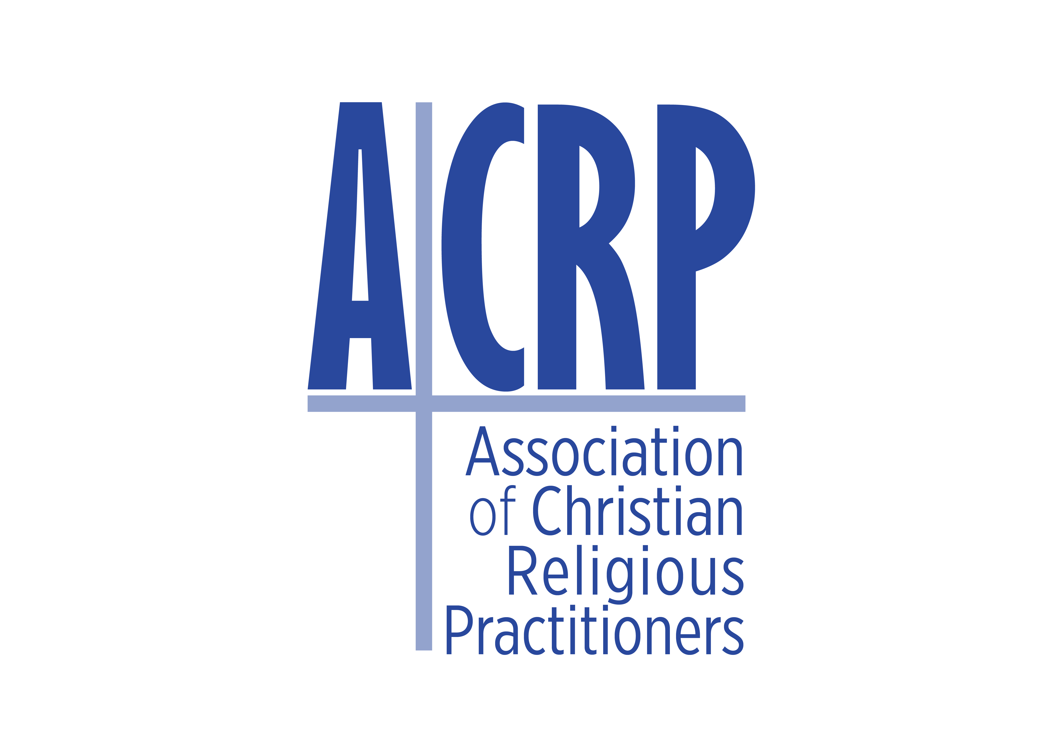
COUNCIL OF GENERAL MINISTRY

PRACTITIONERS (CGMP) ______________________________________________

ATTENDEE 2024 CGMP AUTUMN CONFERENCE REGISTRATION FORM
CGMP CPD points: 8 (5 + 3 for ethics)

Fee for 2024 CGMP AUTUMN Conference Attendees:
R240 for all active 2024 ACRP Affiliates and registered Student Affiliates
R480 for non-affiliates

- Please pay the exact required amount into the ACRP bank account as this also indicates to the ACRP Office that it is the registration payment for the 2024 CGMP Conference.

- Please send the proof of payment and the registration form to acrp@acrpafrica.co.za
- Please use the correct reference: SurnameInitialsCONF24

Banking details:
The link to the conference and documents will not be distributed before the payment thereof reflects in the ACRP bank account.

ABSA
Account name: ACRP
Account Number: 4085403421
Branch Code: 632005
Account type: Cheque
NB Final date for registration: Friday 29 March 2024
Full names and surname (will be used on the CGMP CPD certificate):
Registration number if a registered affiliate of one of the ACRP Councils:
Identification number if not an ACRP Affiliate:
Email address (NB! Must use same email address for conference registration and conference login!):
Cell phone number (Please ensure that this number can be used for WhatsApp communication!):
- Reference for payment: SurnameInitialsCONF24
Compulsory: Please supply us with a single line question about the challenges faced by pastors/ministers/counsellors regarding GBV and poverty in our communities.
Questions will be selected to be addressed by experts during the Roundtable discussion.

I confirm that: | # The correct amount has been paid into the ABSA ACRP account. Y / N
I confirm that: | # The correct reference has been used Y / N
I confirm that: | # The POP has been sent to acrp@acrpafrica.co.za Y/N
I confirm that: | # The completed form will be sent to: acrp@acrpafrica.co.za Y / N
I confirm that: | # I have submitted a question! Y / N
PLEASE SEND TO acrp@acrpafrica.co.za

